Technical Comparison: Blazor vs Razor for AngularJS Migration
Current Implementation Analysis
Task Card Issues in Current Razor Implementation
CSS Grid Conflicts: Fixed width constraints require explicit styling to prevent expansion
Icon Rendering: FontAwesome icons need hardcoding due to lack of dynamic binding
Status Updates: Require full page reloads or complex JavaScript for reactivity
State Management: Manual DOM manipulation for status changes and progress updates
Blazor vs Razor Comparison
1. Task Card Component Management

2. Hybrid Compatibility Assessment
✅ .NET 8 Project Supports Blazor Integration:

Current Program.cs can be extended with Blazor services
Existing MVC controllers can coexist with Blazor components
Entity Framework context is already configured and shareable

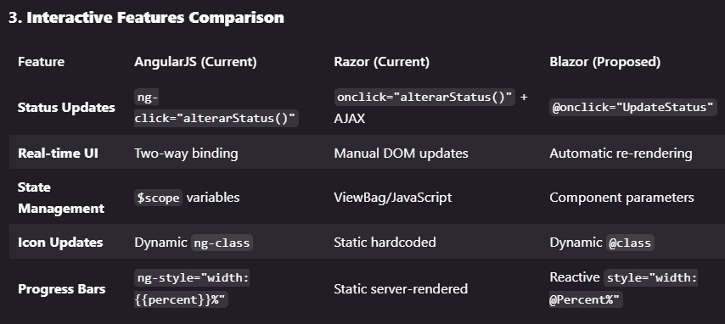

4. Migration Path Analysis
Option A: Pure Razor (Current Path)

Pros:
Minimal architectural changes
Leverages existing MVC knowledge
Faster initial migration

Cons:
Requires complex JavaScript for reactivity
Manual DOM manipulation for status updates
CSS grid issues persist
No real-time updates without SignalR + custom JS

Option B: Hybrid Blazor Components
Pros:
Component-based architecture (like Angular)
Automatic state management and re-rendering
Clean separation of concerns
Real-time updates with SignalR integration
CSS scoping eliminates grid conflicts

Cons:
Learning curve for Blazor
Mixed rendering models (Server + Client)
Slightly more complex initial setup

5. Recommended Hybrid Implementation Strategy
Phase 1: Blazor Components for Interactive Elements
Convert _TaskCardPartial.cshtml to TaskCard.razor
Convert _EtapaAccordionPartial.cshtml to EtapaAccordion.razor
Keep existing MVC controllers and views

Phase 2: Real-time Updates
Add SignalR for status change notifications
Implement automatic card updates without page reloads

Phase 3: Progressive Enhancement
Gradually convert other interactive components
Maintain MVC for non-interactive pages (Login, Escolher Obra)

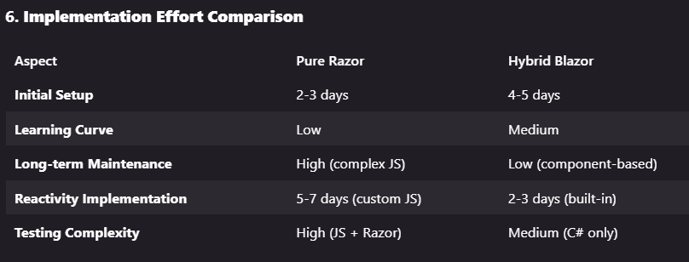

Recommendation
Adopt the Hybrid Blazor Approach for the following reasons:
- Solves Current Issues: Eliminates CSS grid conflicts and icon rendering problems
- Angular-like Development: Component-based architecture familiar to Angular developers
- Future-Proof: Modern .NET approach with better long-term support
- Incremental Migration: Can implement gradually without disrupting existing functionality
- Real-time Capabilities: Built-in support for reactive updates
The hybrid approach provides the best balance between migration effort and long-term maintainability, while solving the current task card width and icon issues more elegantly than pure Razor.

